LAB 6 Performance Analysis for Adders
- Sizing issue for Carry Propagation
- Delay Vs. Voltage
- Find out Critical Path

Truth Table for Full adder：
Input(A，B，Ci) | output(Co) | output(S)
000 | 0 | 0
001 | 0 | 1
010 | 0 | 1
100 | 0 | 1
011 | 1 | 0
101 | 1 | 0
110 | 1 | 0
111 | 1 | 1

Full adder Schematic：
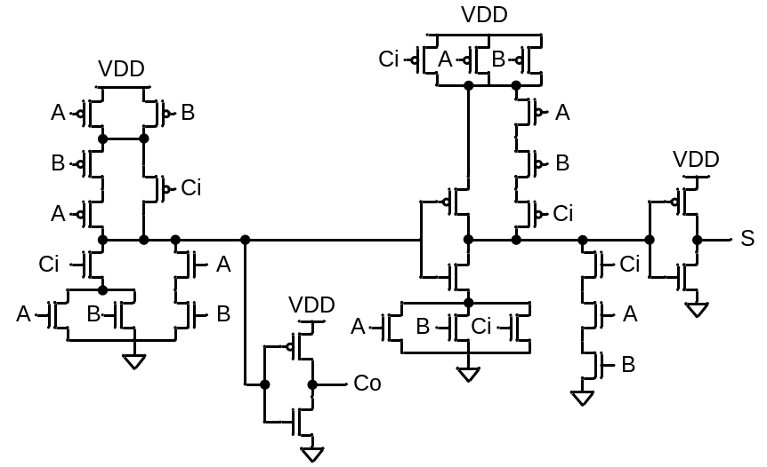
Input pattern：
VA A 0 pulse(1.8 0 1n 0.1n 0.1n 19.9n 40n)
VB B 0 pulse(1.8 0 1n 0.1n 0.1n 39.9n 80n)
VC C 0 pulse(1.8 0 1n 0.1n 0.1n 79.9n 160n)
.tran 0.05n 200n

LAB 6-1 ^{1bit}/_{8bits} Full Adder under Reqular Voltage
6-1-a：(1bit)
Write down a full adder SPICE，Loading 0.1p(for S、C_{out}), Observe Waveform, Delay time, and Power consumption。(Practice Sizing to let Delay smaller than 0.3ns。Delay should be the critical path in the assigned Pattern.) (20%)
6-1-b：(8bits)
Try to connect full adder to be 8-bit carry-ripple adder，Loading 0.1p (for S₀~S₇, C_{o7}), observe waveform, Delay time and Power consumption。(Practice Sizing to let Delay smaller than 0.3ns。Delay should be the critical path in the assigned Pattern.) (20%)

8-bit carry-ripple adder：
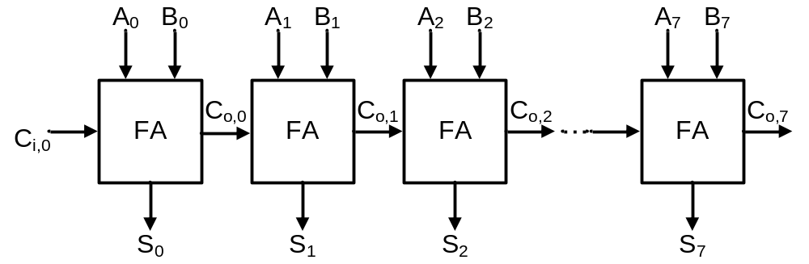

LAB 6-2 ^{1bit}/_{8bits} full adder Under Various Supply Voltage
6-2-a：(1bit)
VDD=1.6V,1.4V, 1.2V, 1.0V, 0.8V, 0.6V，to measure Delay time, Power consumption, and PDP under various supply voltage. (Once 0.2V lower, your input pattern should 10 times slower.) (20%)

